ASR: Micron OFI

## New Screen: Update OFI – FG date

Description:

New function to allow user to re-update FG dates OFI record.

Scan Completed date ,

FG date

## Development specification

### Source table

SCH_OFI_OUTBOUND_SO_LOT

### Sample Screen:

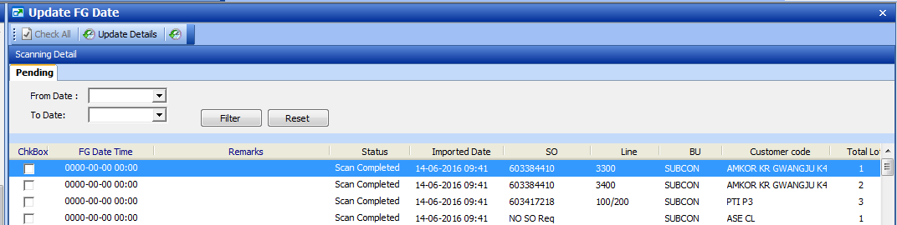

Screen Layout section

* Header
* Detail

Retrieve Section

### Retrieve by:

** Reference to [Update FG Date] function screen.

From Date: SP.ADDDATE

To Date: SP.ADDDATE

Condition: status = ‘9’

### Screen Layout

Detail:

|  |  |  |  |  |  |  |  |  |  |  |
| --- | --- | --- | --- | --- | --- | --- | --- | --- | --- | --- |
| Check | Import date | FG Date | Scan Completed | Remarks | SO | Lineitem | Lot ID | BU | Status | Import No |
|  |  | Editable | Editable | Editable |  |  |  |  |  |  |
|  |  |  |  |  |  |  |  |  |  |  |
|  |  |  |  |  |  |  |  |  |  |  |

Field Mapping:

|  |  |  |
| --- | --- | --- |
| Field name | Data Mapping | Remarks |
| Check |  | Checkbox field |
| Import date | AddDate |  |
| FG Date | FGdatetime | Allow edit, format  Yyyy-mm-dd hh:mm |
| Scan Completed | scancompleteddate | Allow edit, format  Yyyy-mm-dd hh:mm |
| Remarks | Remarks | Allow edit, Required. |
| Parent Lot ID | ParentLotID |  |
| Child Lot ID | ChildLotID |  |
| Parent SO | ParentSO |  |
| Child SO | ChildSO |  |
| BU | BU |  |
| Status | Status |  |
| Import No | Importno |  |

Condition

SQL condition:

SCH_OFI_OUTBOUND_SO_LOT.status = ‘9’

And FGDatetime is not null

### Button Function

[Update detail]

Validate selected row, (check box is selected – checked)

1. Remarks must not be empty. Prompt error message if error.
2. FG Start date/time and scan Completed date must not be future date/time. Prompt error message if error.
3. Scan Start date/time must not be greater than Scan Completed date. Prompt error message if error.
4. Pass validate:

Then update Table fields:

FGDatetime

Scancompleteddate

Remarks

Editdate = Current date

EditWho = Current user